A. -- Create Database (PostgreSQL doesn't usually require explicit CREATE DATABASE)
-- CREATE DATABASE ItemSupplierDB; -- You'd use this in psql or a similar tool
-- \c ItemSupplierDB; -- Connect to the database in psql

-- Create Tables
CREATE TABLE Item (
itemno INT PRIMARY KEY,
Itemname VARCHAR(20),
quantity INT
);

CREATE TABLE Supplier (
SupplierNo INT PRIMARY KEY,
SupplierName VARCHAR(20),
address VARCHAR(50),
city VARCHAR(20)
);

CREATE TABLE Item_sup (
item_no INT,
Supplier_no INT,
Rate DECIMAL(10, 2),
PRIMARY KEY (item_no, Supplier_no),
FOREIGN KEY (item_no) REFERENCES Item(itemno),
FOREIGN KEY (Supplier_no) REFERENCES Supplier(SupplierNo)
);

-- Insert sample data
INSERT INTO Item (itemno, Itemname, quantity) VALUES
(101, 'Laptop', 100),
(102, 'Mouse', 500),
(103, 'Keyboard', 300);

INSERT INTO Supplier (SupplierNo, SupplierName, address, city) VALUES
(201, 'TechSupplies Inc', '123 Main St', 'New York'),
(202, 'GlobalTech Ltd', '456 Oak Ave', 'London'),
(203, 'BestDeals Co', '789 Pine Ln', 'Tokyo');

INSERT INTO Item_sup (item_no, Supplier_no, Rate) VALUES
(101, 201, 1200.00),
(101, 202, 1300.00),
(102, 201, 25.00),
(102, 203, 30.00),
(103, 202, 20.00),
(103, 203, 22.00);

-- Trigger a: Before Update on Rate
CREATE OR REPLACE FUNCTION check_rate_update_func()
RETURNS TRIGGER AS $$
BEGIN
IF (NEW.Rate - OLD.Rate) > 2000 THEN
RAISE EXCEPTION 'Error: Rate increase exceeds Rs 2000.';
END IF;
RETURN NEW;
END;
$$ LANGUAGE plpgsql;

CREATE TRIGGER check_rate_update
BEFORE UPDATE ON Item_sup
FOR EACH ROW
EXECUTE FUNCTION check_rate_update_func();
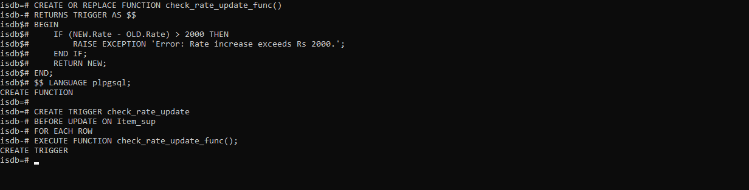

-- Trigger b: Before Insert on Rate
CREATE OR REPLACE FUNCTION check_rate_insert_func()
RETURNS TRIGGER AS $$
BEGIN
IF NEW.Rate = 0 THEN
RAISE EXCEPTION 'Error: Zero rate not allowed.';
END IF;
RETURN NEW;
END;
$$ LANGUAGE plpgsql;

CREATE TRIGGER check_rate_insert
BEFORE INSERT ON Item_sup
FOR EACH ROW
EXECUTE FUNCTION check_rate_insert_func();
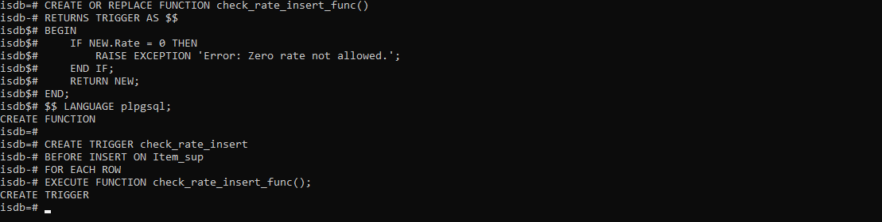
b.
-- Create Database
-- CREATE DATABASE NewspaperDB;
-- \c NewspaperDB;

-- Create Tables
CREATE TABLE Newspaper (
name VARCHAR(20),
language VARCHAR(20),
Publisher VARCHAR(20),
cost DECIMAL(10, 2), -- Using DECIMAL for money
PRIMARY KEY (name)
);

CREATE TABLE Cities (
pincode VARCHAR(6),
city VARCHAR(20),
state VARCHAR(20),
PRIMARY KEY (pincode)
);

CREATE TABLE Newspaper_Cities (
name VARCHAR(20),
pincode VARCHAR(6),
daily_required INTEGER,
PRIMARY KEY (name, pincode),
FOREIGN KEY (name) REFERENCES Newspaper(name),
FOREIGN KEY (pincode) REFERENCES Cities(pincode)
);

-- Insert sample data
INSERT INTO Newspaper (name, language, Publisher, cost) VALUES
('Times of India', 'English', 'Bennett, Coleman & Co.', 5.00),
('Maharashtra Times', 'Marathi', 'Bennett, Coleman & Co.', 4.00),
('The Hindu', 'English', 'Kasturi & Sons Ltd.', 6.00),
('Lokmat', 'Marathi', 'Lokmat Media Pvt Ltd', 3.50);

INSERT INTO Cities (pincode, city, state) VALUES
('400001', 'Mumbai', 'Maharashtra'),
('110001', 'Delhi', 'Delhi'),
('600001', 'Chennai', 'Tamil Nadu'),
('411001', 'Pune', 'Maharashtra');

INSERT INTO Newspaper_Cities (name, pincode, daily_required) VALUES
('Times of India', '400001', 1000),
('Maharashtra Times', '400001', 500),
('The Hindu', '600001', 200),
('Lokmat', '411001', 300),
('Times of India', '110001', 800);

-- Trigger a: Check pincode length before insert into Cities
CREATE OR REPLACE FUNCTION check_pincode_length_func()
RETURNS TRIGGER AS $$
BEGIN
IF LENGTH(NEW.pincode) <> 6 THEN
RAISE EXCEPTION 'Error: Pincode must be 6 digits. The provided pincode % has length %', NEW.pincode, LENGTH(NEW.pincode);
END IF;
RETURN NEW;
END;
$$ LANGUAGE plpgsql;

CREATE TRIGGER check_pincode_length
BEFORE INSERT ON Cities
FOR EACH ROW
EXECUTE FUNCTION check_pincode_length_func();

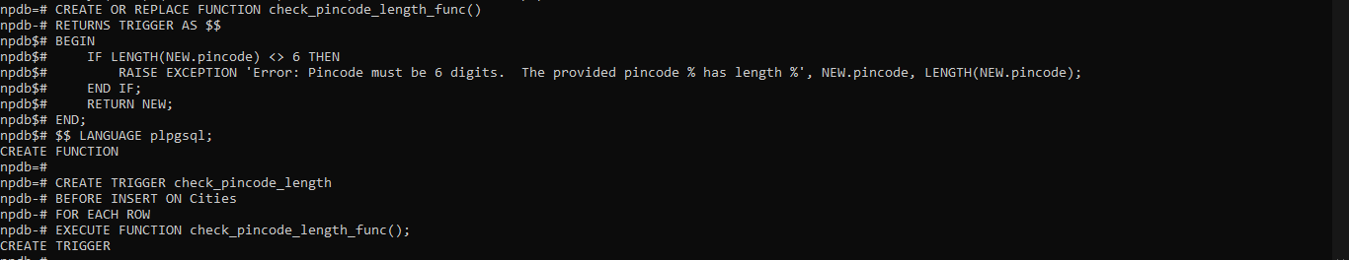
-- Trigger b: Prevent deleting cities from Maharashtra state
CREATE OR REPLACE FUNCTION prevent_delete_maharashtra_func()
RETURNS TRIGGER AS $$
BEGIN
IF OLD.state = 'Maharashtra' THEN
RAISE EXCEPTION 'Error: Cannot delete cities from Maharashtra.';
END IF;
RETURN OLD;
END;
$$ LANGUAGE plpgsql;

CREATE TRIGGER prevent_delete_maharashtra
BEFORE DELETE ON Cities
FOR EACH ROW
EXECUTE FUNCTION prevent_delete_maharashtra_func();

